We are a consulting group that’s been hired by a client who is moving to the west coast and needs to find options that can accommodate their medical condition, which requires frequent trips to the hospital for special care. We will use a large dataset from Kaggle that offers lots of information on several hospitals across the country. We will filter this down to locations in CA, OR, and WA, then narrow down choices based on 5-star ratings, proximity to metropolitan areas, and other variables, to be displayed in our visualizations.

* Map of west coast hospitals/cluster map of best ratings
* Bar chart for hospital ownership types (could help determine if client’s insurance will be accepted)
* Drop down menu on an interactive visualization that allows the client to toggle between different hospital characteristics to see what’s available in a given area.

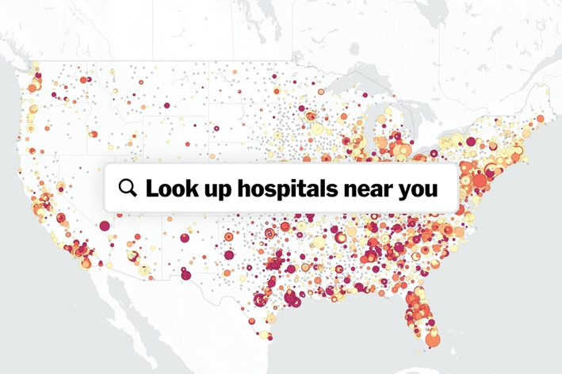

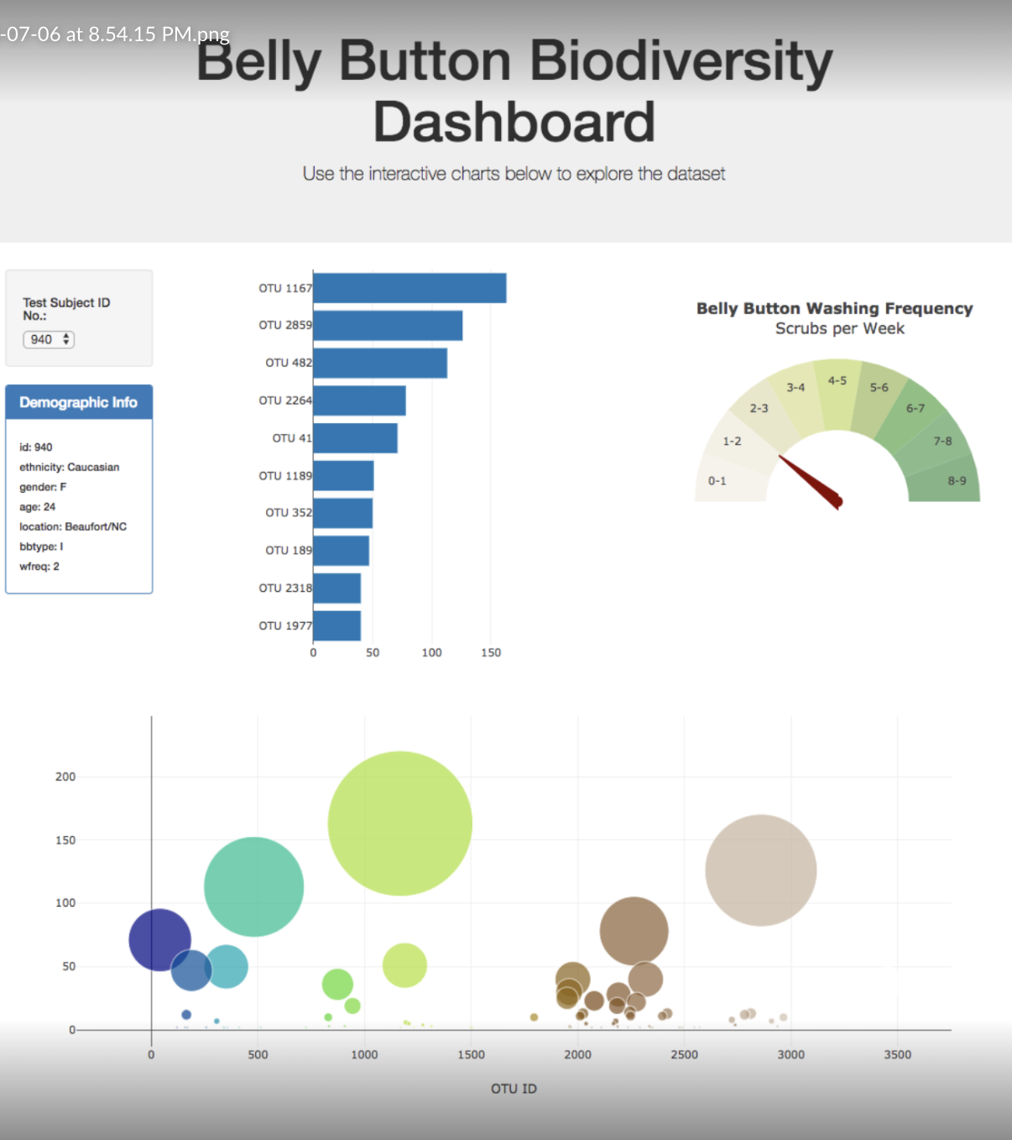

GitHub: <https://github.com/sydneysteele03/project-3>

Link to Metadata: https://www.kaggle.com/datasets/thedevastator/hospitals-in-the-united-states-a-comprehensive-d